**Friendship Zone App**

**Objective of Project:** Friendship Zone is a web application, where an individual can connect with his/her friends.

**Problem Statement(s):** Lack of Beginner-Friendly Social Platforms: Most social platforms are either overly complex or require backend integration. Beginners need a front-end-only model to practice JavaScript.

No Easy Way to Simulate Friend Lists: Users often struggle to build or visualize friend-based connections in basic web apps.

**Code Pen Link:**

**Output:**

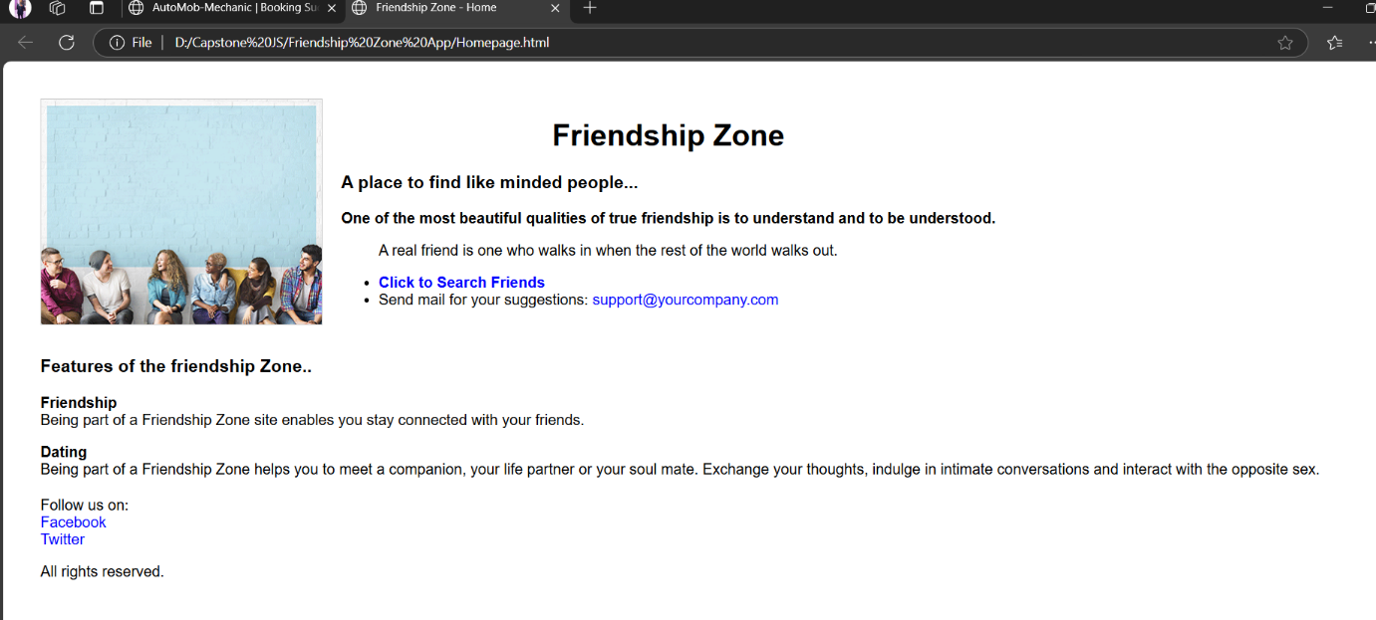

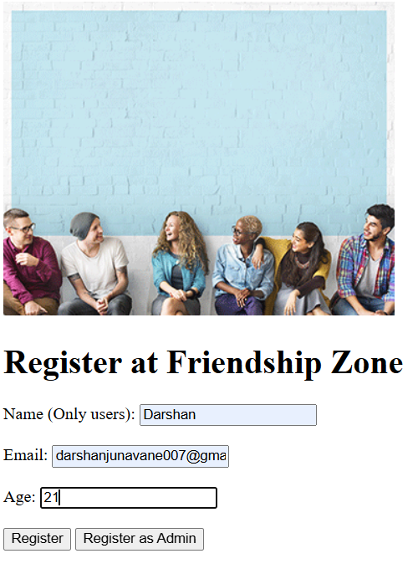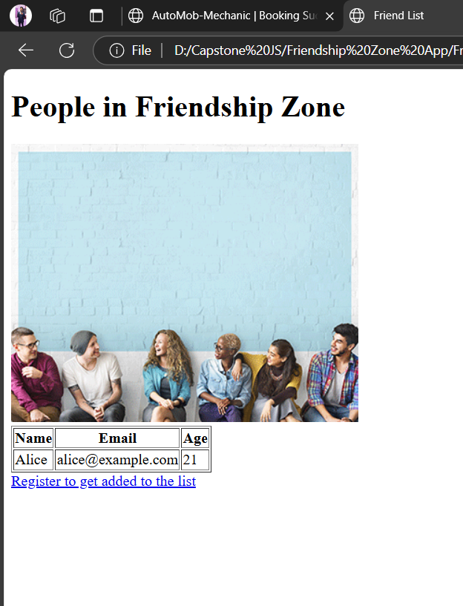

**Conclusion and Outcome:** The app allows users to manage a dynamic friend list.